Weak points in C programming:

Unit 2:

Conditional operator:

Conditional operator is similar to if- else operator.

The conditional operator is kind of similar to the [if-else statement](https://www.geeksforgeeks.org/decision-making-c-c-else-nested-else/) as it does follow the same algorithm as of [if-else statement](https://www.geeksforgeeks.org/decision-making-c-c-else-nested-else/) but the conditional operator takes less space and helps to write the if-else statements in the shortest way possible.

[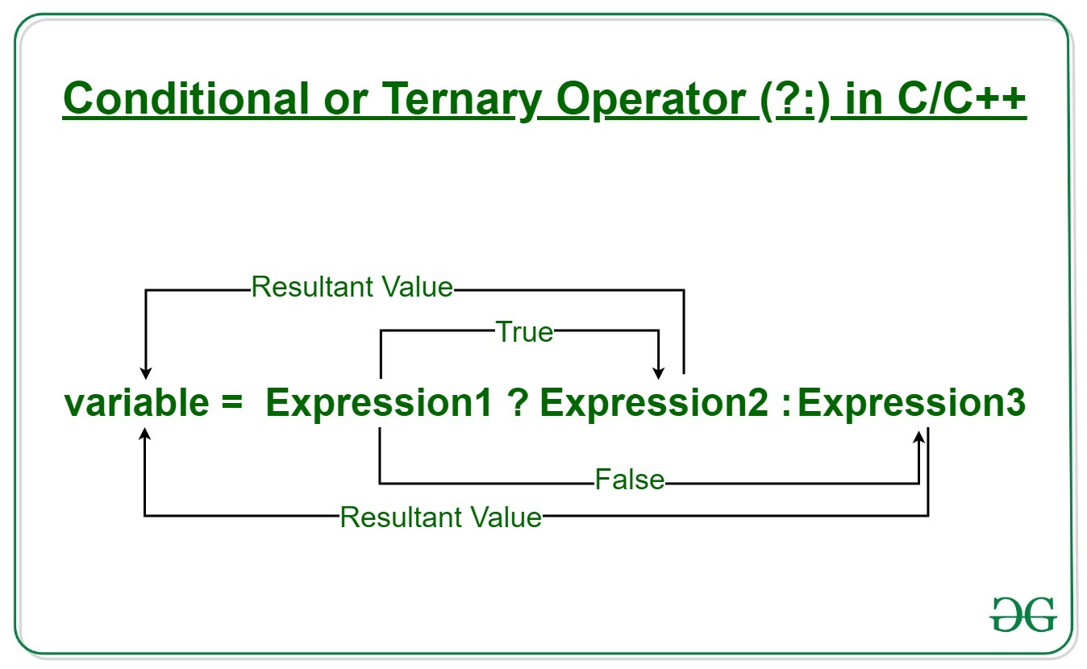](https://media.geeksforgeeks.org/wp-content/uploads/20190920110229/Conditional-or-Ternary-Operator-__-in-C_C.jpg)

**Syntax:**   
The conditional operator is of the form

*variable = Expression1 ? Expression2 : Expression3*

Or the syntax will also be in this form

*variable = (condition) ? Expression2 : Expression3*

Or syntax will also be in this form

*(condition) ? (variable = Expression2) : (variable = Expression3)*

It can be visualized into if-else statement as:

if(Expression1)

{

variable = Expression2;

}

else

{

variable = Expression3;

}

Since the Conditional Operator ‘?:’ takes three operands to work, hence they are also called **ternary operators**.  
**Working:**   
Here, **Expression1** is the condition to be evaluated. If the condition(**Expression1**) is True then **Expression2**will be executed and the result will be returned. Otherwise, if the condition(**Expression1**) is false then **Expression3**will be executed and the result will be returned.

[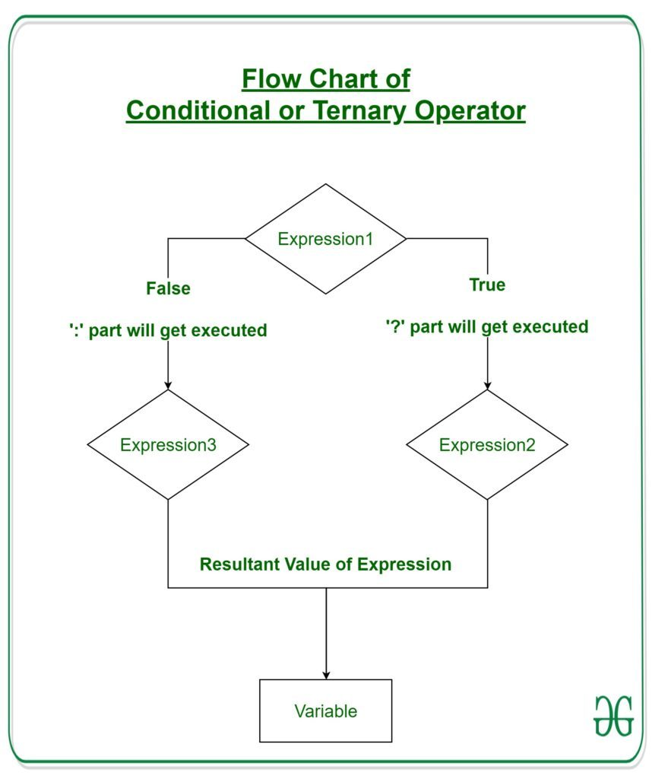](https://media.geeksforgeeks.org/wp-content/uploads/20190920114837/Flow-Chart-of-Conditional-or-Ternary-Operator-__-in-C_C.jpg)

**Example 1:** Program to Store the greatest of the two Number.

* C
* C++

|  |
| --- |
| // C program to find largest among two  // numbers using ternary operator    #include <stdio.h>    **int** main()  {  **int** m = 5, n = 4;        (m > n) ? **printf**("m is greater than n that is %d > %d",                       m, n)              : **printf**("n is greater than m that is %d > %d",                       n, m);    **return** 0;  } |

**Output**

m is greater than n that is 5 > 4

**Example 2:** Program to check whether a year is leap year or not.

* C
* C++

|  |
| --- |
| // C program to check whether a year is leap year or not  // using ternary operator    #include <stdio.h>    **int** main()  {  **int** yr = 1900;        (yr%4==0) ? (yr%100!=0? **printf**("The year %d is a leap year",yr)       : (yr%400==0 ? **printf**("The year %d is a leap year",yr)           : **printf**("The year %d is not a leap year",yr)))               : **printf**("The year %d is not a leap year",yr);  **return** 0;  }    //This code is contributed by Susobhan AKhuli |

**Output**

The year 1900 is not a leap year